**NAAN MUDHALVAN – IBM PROJECT**

**COLLEGE NAME : JEPPIAAR ENGINEERING COLLEGE**

**COLLEGE CODE : 3108**

**DOMAIN : CLOUD APPLICATION DEVELOPMENT**

**PROJECT : 10.MEDIA STREAMING WITH IBM CLOUD VIDEO STREAMING**

**TEAM** **MEMBERS** :

1. **SUCHARITHA.N** (au310821106090)
2. **SUBHASHINI.N** (au310821106088)
3. **VAISHNAVI.K.A** (au310821106101)
4. **PRIYA.R** (au310821106062)

**PHASE 3 : DEVELOPMENT PART 1**

**INTRODUCTION :**

In this project, you will begin building your project using IBM cloud

Video streaming . Perform different functions as per project requirement .Define

the platform features and design an intuitive user interface.Build a user registration

and authentication mechanisms to ensure secure access to the platform.

**OBJECTIVES :**

The main objective is to create a virtual cinema platform using IBM

Cloud video streaming.This platform allow users to upload and store their favourite

Movies and videos for on-demand streaming. We aim to define the implementation

Of user registration and authentication mechanisms, to ensure and secure cinematic

experience for our users and implementation of home page for users needs.

**USER REGISTRATION AND AUTHENTICATION MECHANISMS :**

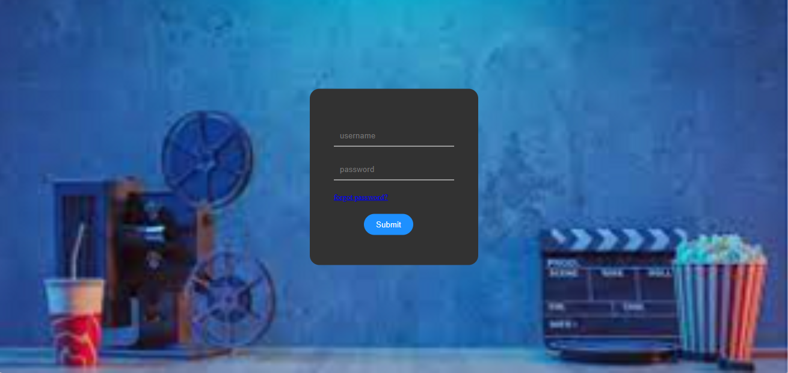

This involve the implementation of robust system that allows users to create

an accounts securely , customize their experience and ensure data privacy . This involves

multi-factor authentication with industry standards to secure access to our virtual cinema

platform and it also contains a forget password option and it also includes authentication

mechanisms. We have created the platform using html, CSS and Java .

**Code for user login :**

<html>

<head>

<tittle>VIRTUAL CINEMA LOGIN PLATFORM</tittle>

<style>

body{

margin:0;

padding:0;

background-image:url(background.jpg.png);

background-size: cover;

}

.container{

top:50%;

left:50%;

position:absolute;

transform:translate(-50%,-50%);

}

.card{

padding:60px 40px 50px 40px;

background:rgb(50,50,50);

border-radius:16px;

margin-bottom:10px;

}

#name{

width: 200px;

border:none;

background:transparent;

border-bottom:1px solid white;

padding:10px;

margin-bottom:20px;

color: white;

}

#button{

border-radius:20px;

padding:10px 20px;

background: dodgerblue;

color:white;

margin-top:20px;

border:none;

outline: none;

margin-left:50px;

}

a{

font-size: 13px;

}

</style>

</head>

<body>

<div class="container">

<div class="card">

<input type="text" placeholder="username" id="name"><br>

<input type="password" placeholder="password" id="name"><br>

<a href="#">forgot password?</a><br>

<input type="submit" value="Submit" id="button">

<body>

</html>

**HOME PAGE :**

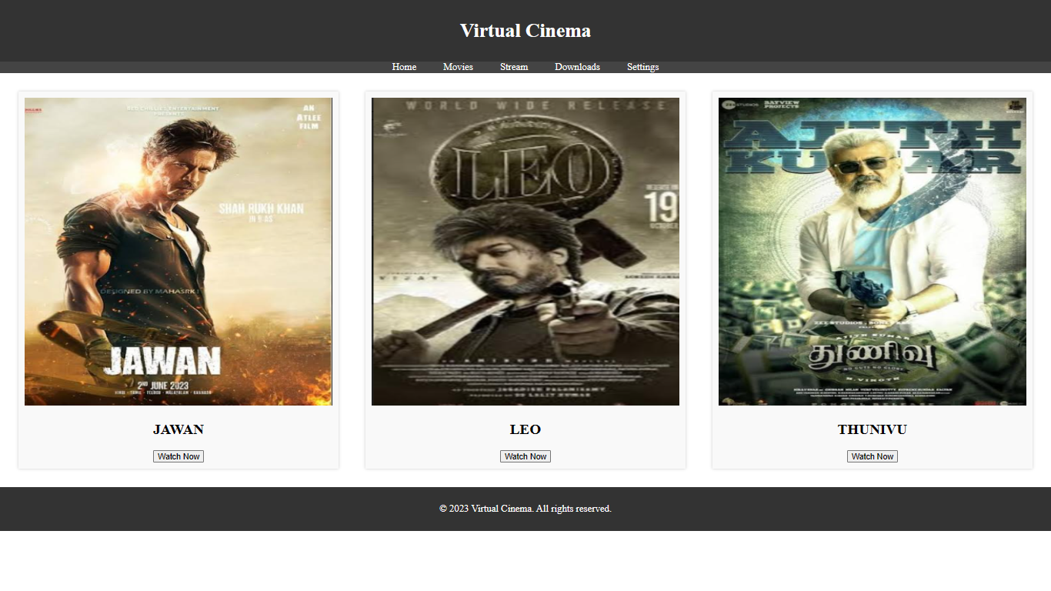

Implementation of creating an aesthetically pleasing and user-friendly interface,ensuring that

users can seamlessly navigate, discover content and enjoy an immersive cinematic experience .We

have created this platform using HTML, CSS, Javascript .

**Code for home page:**

<!DOCTYPE html>

<html>

<head>

<title>Virtual Cinema</title>

<link rel="stylesheet" type="text/css" href="styles.css">

<style>

/* Reset default margin and padding */

body, ul {

margin: 0;

padding: 0;

}

/* Style the header */

header {

background-color: #333;

color: #fff;

text-align: center;

padding: 10px 0;

}

/* Style the navigation menu */

nav ul {

background-color: #444;

list-style: none;

text-align: center;

}

nav ul li {

display: inline;

margin: 0 20px;

}

nav ul li a {

text-decoration: none;

color: #fff;

}

/* Style the movie listings */

.movie-list {

display: flex;

justify-content: space-between;

flex-wrap: wrap;

padding: 20px;

}

.movie {

width: 30%;

background-color: #f9f9f9;

padding: 10px;

margin: 10px;

box-shadow: 0 0 5px rgba(0, 0, 0, 0.2);

text-align: center;

}

.movie img {

width: 100%;

}

/* Style the user panel */

.user-panel {

background-color: #f9f9f9;

padding: 10px;

margin: 10px;

box-shadow: 0 0 5px rgba(0, 0, 0, 0.2);

}

/* Style the footer */

footer {

background-color: #333;

color: #fff;

text-align: center;

padding: 10px 0;

}

</style>

</head>

<body>

<header>

<h1>Virtual Cinema</h1>

</header>

<nav>

<ul>

<li><a href="#">Home</a></li>

<li><a href="#">Movies</a></li>

<li><a href="#">Stream</a></li>

<li><a href="#">Downloads</a></li>

<li><a href="#">Settings</a></li>

</ul>

</nav>

<section class="movie-list">

<article class="movie">

<img src="jawan poster.png" width="300" height="500" alt="jawan">

<h2>JAWAN</h2>

<button>Watch Now</button>

</article>

<article class="movie">

<img src="leo poster.png" width="300" height="500"

alt="leo">

<h2>LEO</h2>

<button>Watch Now</button>

</article>

<article class="movie">

<img src="thunivu poster.png"

width="300" height="500" alt="thunivu">

<h2>THUNIVU</h2>

<button>Watch Now</button>

</article>

<!-- Add more movie listings here -->

</section>

<footer>

<p>&copy; 2023 Virtual Cinema. All rights reserved.</p>

</footer>

</body>

</html>

**CONCLUSION :**

This Phase 3 : Development part1 plays an important role in creating our virtual cinema

Platform. It defines the implementation of user registration and authentication mechanisms, to

ensure and secure cinematic experience for our users. In conclusion , creating a virtual cinema

platform using IBM cloud video streaming opens Up new opportunities for bringing people

together through shared cinematic experiences.